TRIBHUVAN UNIVERSITY
PATAN MULTIPLE CAMPUS
PATANDHOKA, LALITPUR

NET CENTRIC COMPUTING (BIT 351)

SUBMITTED BY: | SUBMITTED TO:
NAME: SURESH DAHAL | SUBASH SIWA
ROLL: 23
CLASS: BIT-III/II | ___________________
DATE: 2083/05/15 | CHECKED BY

UNIT-6
- Implementing Server-Side State Management in ASP.NET Core.

OUTPUT:
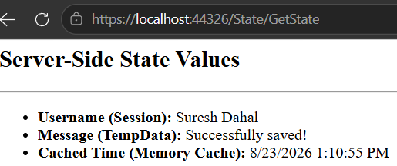
First load

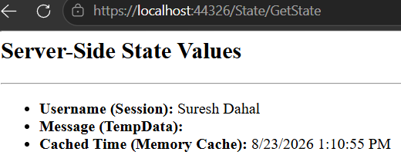
After refresh

- Implementing Client-Side State Management
PROGRAM:
1. Create MVC Application
dotnet new mvc -n StateDemo
cd StateDemo

2. Controller
using Microsoft.AspNetCore.Mvc;

namespace StateMgmtClientSide.Controllers;

public class ClientStateController : Controller
{
[HttpGet]
public IActionResult Index(string? name, int? age)
{
ViewBag.Name = name;
ViewBag.Age = age;
ViewBag.Theme = Request.Cookies["Theme"] ?? "Not Set";

return View();
}

[HttpGet]
public IActionResult SaveCookie(string theme)
{
Response.Cookies.Append("Theme", theme);

return RedirectToAction("Index");
}

[HttpGet]
public IActionResult DeleteCookie()
{
Response.Cookies.Delete("Theme");

return RedirectToAction("Index");
}

[HttpPost]
public IActionResult SubmitForm(int userId, string name)
{
ViewBag.Result =
$"User ID: {userId}, Name: {name}";

ViewBag.Theme =
Request.Cookies["Theme"] ?? "Not Set";

return View("Index");
}
}

3. View
<h2>Client-Side State Management</h2>
<hr />
<h3>1. Cookie</h3>

<a href="/ClientState/SaveCookie?theme=Dark">
Save Cookie
</a>

<p>
Current Theme:
<b>@ViewBag.Theme</b>
</p>

<a href="/ClientState/DeleteCookie">
Delete Cookie
</a>

<hr />

<h3>2. Query String</h3>

<p>
Name: <b>@ViewBag.Name</b>
<br />
Age: <b>@ViewBag.Age</b>
</p>

<a href="/ClientState?name=Suresh&age=26">
Send Name and Age using Query String
</a>
<hr />
<h3>3. Hidden Field</h3>

<form action="/ClientState/SubmitForm" method="post">

<input type="hidden"
name="userId"
value="101" />

<label>Name:</label>

<input type="text"
name="name"
placeholder="Enter name" />

<button type="submit">
Submit
</button>

</form>

@if (ViewBag.Result != null)
{
<p>
<b>@ViewBag.Result</b>
</p>
}
OUTPUT:
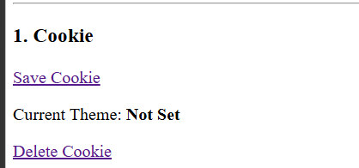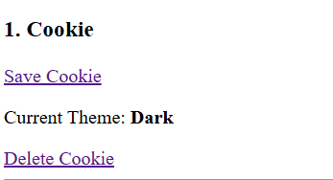
Before setting cookie after setting cookie

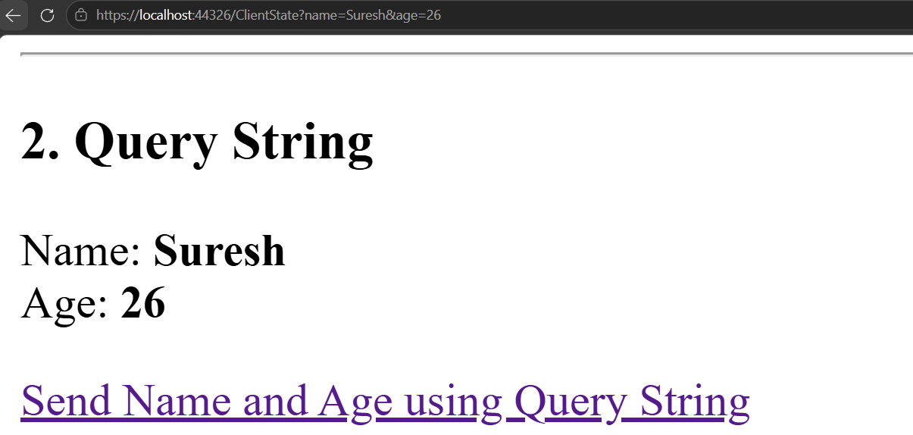
Query String

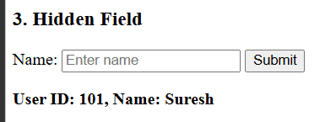
Hidden Field

UNIT – 7
- Client-Side Dynamic Web Development with jQuery and AJAX
THEORY:
jQuery is a JavaScript library used for simplifying client-side web development. It provides easy methods for selecting HTML elements, handling events, manipulating the DOM, validating forms, and communicating with servers using AJAX.
AJAX (Asynchronous JavaScript and XML) allows a web page to communicate with a server without refreshing the entire page. In an ASP.NET Core application, jQuery can send AJAX requests to Web API REST endpoints and receive data, usually in JSON format.
Advantages of jQuery
- Simple and easy-to-use syntax.
- Simplifies DOM manipulation.
- Provides convenient event handling.
- Supports AJAX communication.
- Allows dynamic page updates without refreshing the browser.

PROGRAM

1. ASP.NET Core Web API
Create the project:
dotnet new webapi -n StudentApi
cd StudentApi
Create Models/Student.cs:
namespace StudentApi.Models
{
public class Student
{
public int Id { get; set; }
public string Name { get; set; } = "";
public string Email { get; set; } = "";
}
}
Create Controllers/StudentsController.cs:
using Microsoft.AspNetCore.Mvc;
using StudentApi.Models;

namespace StudentApi.Controllers
{
[ApiController]
[Route("api/[controller]")]
public class StudentsController : ControllerBase
{
private static List<Student> students = new()
{
new Student
{
Id = 1,
Name = "Suresh",
Email = "suresh@gmail.com"
},
new Student
{
Id = 2,
Name = "Luna",
Email = "Luna@gmail.com"
}
};

[HttpGet]
public IActionResult GetStudents()
{
return Ok(students);
}

[HttpPost]
public IActionResult AddStudent(Student student)
{
student.Id = students.Count + 1;
students.Add(student);

return Ok(student);
}
}
}
Run the API:
dotnet run

2. Client-side HTML, CSS and jQuery
Create index.html:
<!DOCTYPE html>
<html>
<head>
<title>Student Management</title>
<script src="https://code.jquery.com/jquery-3.7.1.min.js"></script>
<style>
body {
font-family: Arial;
margin: 40px;
}
input {
padding: 8px;
margin: 5px;
}
button {
padding: 8px 15px;
}
li {
margin: 8px;
}
.error {
color: red;
font-size: 14px;
}
</style>
</head>
<body>
<h1>Student Management</h1>
<form id="studentForm">
<input type="text" id="name" placeholder="Enter name">
<span id="nameError" class="error"></span>
<br>
<input type="text" id="email" placeholder="Enter email">
<span id="emailError" class="error"></span>
<br>
<button type="submit">Add Student</button>
</form>
<br>
<button id="loadStudents">Load Students</button>
<ul id="studentList"></ul>
<script>
$("#loadStudents").click(function () {
$.ajax({
url: "https://localhost:44321/api/students",
type: "GET",
success: function (students) {
$("#studentList").empty();
$.each(students, function (index, student) {
$("#studentList").append(
"<li>" + student.id + " - " +
student.name + " - " +
student.email +
"</li>"
);
});
},
error: function () {
alert("Error loading students.");
}
});
});
$("#studentForm").submit(function (event) {
event.preventDefault();
$("#nameError").text("");
$("#emailError").text("");
var name = $("#name").val().trim();
var email = $("#email").val().trim();
var valid = true;
if (name === "") {
$("#nameError").text("Name is required.");
valid = false;
}
var emailPattern =
/^[^\s@]+@[^\s@]+\.[^\s@]+$/;
if (email === "") {
$("#emailError").text("Email is required.");
valid = false;
}
else if (!emailPattern.test(email)) {
$("#emailError").text("Enter a valid email.");
valid = false;
}
if (!valid) return;
var student = {
name: name,
email: email
};
$.ajax({
url: "https://localhost:44321/api/students",
type: "POST",
contentType: "application/json",
data: JSON.stringify(student),
success: function (student) {
$("#studentList").append(
"<li>" + student.id + " - " +
student.name + " - " +
student.email +
"</li>"
);
$("#studentForm")[0].reset();
},
error: function () {
alert("Error adding student.");
}
});
});
</script>
</body>
</html>
OUTPUT:
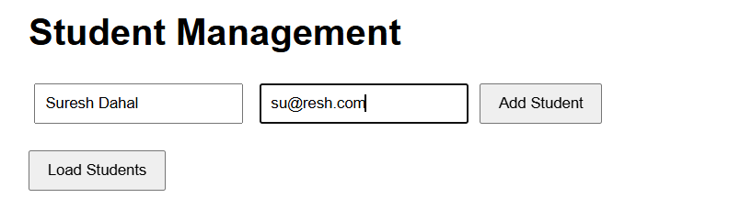
Add students
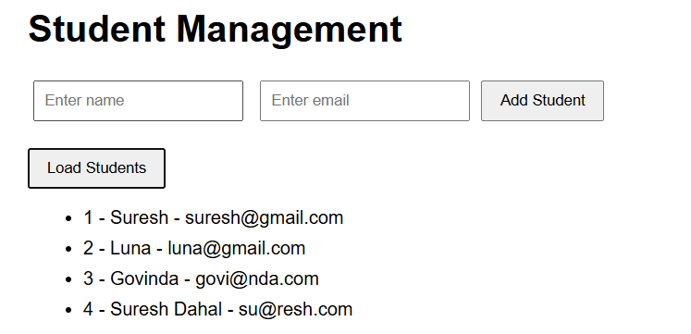
Load all students
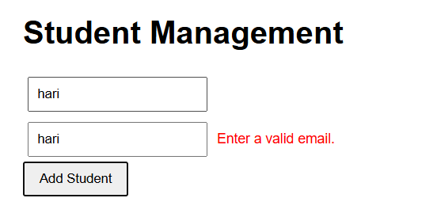
Client-side validation using jQuery

- jQuery vs. Modern Frontend Frameworks
THEORY:
- jQuery: An imperative DOM manipulation library. You manually select elements and explicitly tell the browser how to update the DOM step-by-step. It is lightweight and easy to drop into legacy or small-scale multi-page applications.
- Modern Frameworks: Component-based, declarative UI libraries/frameworks designed for building large-scale Single Page Applications.
- Key Comparisons:
  - Architecture: jQuery handles individual elements imperatively; modern frameworks use reusable components with a reactive Component Lifecycle.
  - Data Binding: jQuery requires manual reading/writing of values between UI inputs and variables. Modern frameworks feature Two-Way (Angular/Vue) or One-Way Data Binding with Virtual DOM (React) that synchronizes state and UI automatically.
  - State Management & Scaling: jQuery code can become difficult to maintain as an app grows. Modern frameworks provide structured state management ecosystems optimized for complex enterprise applications.

Practical Comparison Table
Feature / Aspect | jQuery | Modern Frameworks
Approach | Imperative | Declarative
Structure | Script-based manipulation of global DOM elements | Component-based, modular architecture
Data Synchronization | Manual (e.g., $('#input').val()) | Automatic via Data Binding & State Management
Best Used For | Small apps, widget enhancements, legacy apps | Large-scale Single Page Applications

Example
jQuery:
$("#message").text("Hello World");

React:
function App() {
return <h1>Hello World</h1>;
}

In jQuery, the developer directly selects and modifies DOM elements. In React, the interface is organized into reusable components and is updated based on application state.

UNIT – 8:
- Implementing Authentication Using ASP.NET Core Identity
THEORY
ASP.NET Core Identity is a membership system that provides authentication and user-management functionality for ASP.NET Core applications. It manages users, passwords, roles, claims, login, logout, and password-related operations.
The basic authentication process is:
User
↓
Login/Register
↓
ASP.NET Core Identity
↓
Identity Database
↓
Authentication Cookie
↓
Authorized Application

PRACTICAL IMPLEMENTATION
Step 1: Create MVC Application
dotnet new mvc -n IdentityDemo
cd IdentityDemo

Install Identity and Entity Framework Core packages:
dotnet add package Microsoft.AspNetCore.Identity.EntityFrameworkCore
dotnet add package Microsoft.EntityFrameworkCore.Sqlite
dotnet add package Microsoft.EntityFrameworkCore.Tools

Step 2: Create Identity DbContext
Create Data/AppDbContext.cs:
using Microsoft.AspNetCore.Identity.EntityFrameworkCore;
using Microsoft.EntityFrameworkCore;
namespace IdentityDemo.Data;

public class AppDbContext
: IdentityDbContext
{
public AppDbContext(DbContextOptions<AppDbContext> options)
: base(options) { }
}

Step 3: Configure Identity
In Program.cs:
using IdentityDemo.Data;
using Microsoft.AspNetCore.Identity;
using Microsoft.EntityFrameworkCore;

var builder = WebApplication.CreateBuilder(args);

builder.Services.AddDbContext<AppDbContext>(options =>
options.UseSqlite(
builder.Configuration.GetConnectionString("DefaultConnection")));

builder.Services.AddDefaultIdentity<IdentityUser>(options =>
{
options.SignIn.RequireConfirmedAccount = false;
options.Password.RequireDigit = true;
options.Password.RequiredLength = 6;
})
.AddEntityFrameworkStores<AppDbContext>();

builder.Services.AddControllersWithViews();

var app = builder.Build();
app.UseHttpsRedirection();
app.UseStaticFiles();

app.UseRouting();

app.UseAuthentication();
app.UseAuthorization();

app.MapControllerRoute(
name: "default",
pattern: "{controller=Home}/{action=Index}/{id?}");

app.MapRazorPages();
app.Run();

Step 4: Configure Database
Add the following to appsettings.json:
{
"ConnectionStrings": {
"DefaultConnection": "Data Source=identity.db"
}
}
Create the Identity database:
dotnet ef migrations add InitialIdentity
dotnet ef database update
This creates database and Identity tables.

Step 5: Create Authentication Controller
Create Controllers/AccountController.cs:
using Microsoft.AspNetCore.Identity;
using Microsoft.AspNetCore.Mvc;

namespace IdentityDemo.Controllers;

public class AccountController : Controller
{
private readonly UserManager<IdentityUser> _users;
private readonly SignInManager<IdentityUser> _signIn;

public AccountController(
UserManager<IdentityUser> users,
SignInManager<IdentityUser> signIn)
{
_users = users;
_signIn = signIn;
}

[HttpGet]
public IActionResult Register() => View();

[HttpPost]
public async Task<IActionResult> Register(string email, string password)
{
var user = new IdentityUser { UserName = email, Email = email };

var result = await _users.CreateAsync(user, password);

if (result.Succeeded)
{
await _signIn.SignInAsync(user, false);
return RedirectToAction("Index", "Home");
}

ViewBag.Error = "Registration failed.";
return View();
}

[HttpGet]
public IActionResult Login() => View();

[HttpPost]
public async Task<IActionResult> Login(string email, string password)
{
var result = await _signIn.PasswordSignInAsync(
email, password, false, false);

if (result.Succeeded)
return RedirectToAction("Index", "Home");

ViewBag.Error = "Invalid email or password.";
return View();
}

public async Task<IActionResult> Logout()
{
await _signIn.SignOutAsync();
return RedirectToAction("Index", "Home");
}
}

Step 6: Register View
Create Views/Account/Register.cshtml:
<h2>Register</h2>
<form method="post">
<input name="email" type="email" placeholder="Email" required />
<input name="password" type="password"
placeholder="Password" required />
<button type="submit">Register</button>
</form>

@if (ViewBag.Error != null) {
<p>@ViewBag.Error</p>
}

Step 7: Login View
Create Views/Account/Login.cshtml:
<h2>Login</h2>
<form method="post">
<input name="email" type="email" placeholder="Email" required />
<input name="password" type="password"
placeholder="Password" required />
<button type="submit">Login</button>
</form>
@if (ViewBag.Error != null) {
<p>@ViewBag.Error</p>
}

Step 8: Protect a Controller
Modify HomeController.cs:
using Microsoft.AspNetCore.Authorization;
using Microsoft.AspNetCore.Mvc;
public class HomeController : Controller
{
[AllowAnonymous]
public IActionResult Index() {
return View();
}

[Authorize]
public IActionResult Dashboard() {
return View();
}
}
[AllowAnonymous] allows anyone to access the action.
[Authorize] allows only authenticated users to access the action.

OUTPUT:
Add Packages
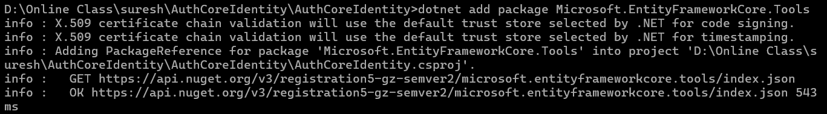
dotnet ef migrations add InitialIdentity
dotnet ef database update
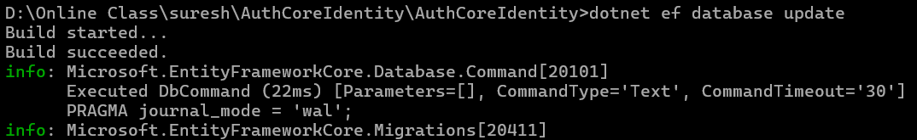
Registration
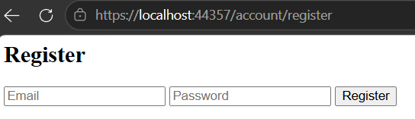
Login
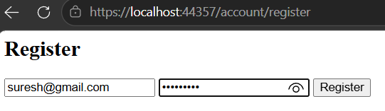

Successful registration redirects to home page

Protected page
/Home/Dashboard
Without authentication:
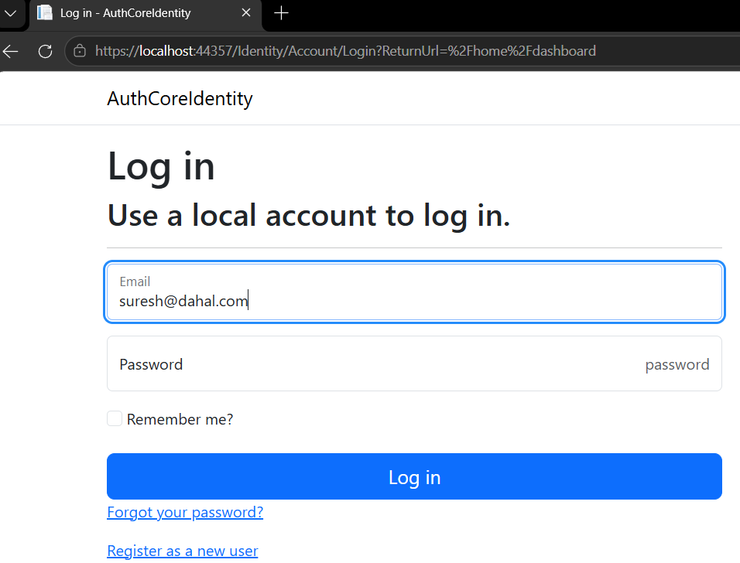
After login:
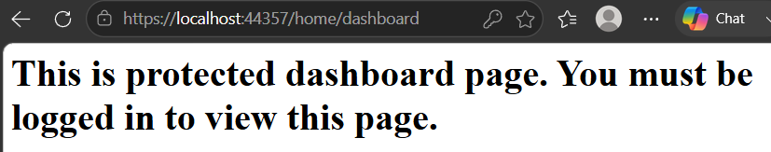

- Implementing Authorization Using Roles, Claims, and Policies
Theory
Authorization determines what authenticated user is allowed to access. ASP.NET Core supports role-based, claim-based, and policy-based authorization.
- Role: It groups users according to their responsibilities, such as Admin, Faculty, or Student.
- Claim: It is a piece of information about a user, such as department or permission.
- Policy: It is a rule that determines whether a user can access a resource based on roles, claims, or other requirements.
ASP.NET Core provides attributes such as:
- [Authorize] allows only authenticated users.
- [AllowAnonymous] allows everyone, including unauthenticated users.
- [Authorize(Roles = "Role")] restricts access to a specific role.
- [Authorize(Policy = "PolicyName")] restricts access according to a policy.

Practical Implementation
1. Configure Roles
Program.cs
using AuthCoreIdentity.Data;
using Microsoft.AspNetCore.Identity;
using Microsoft.EntityFrameworkCore;

var builder = WebApplication.CreateBuilder(args);

builder.Services.AddDbContext<AppDbContext>(options =>
options.UseSqlite(
builder.Configuration.GetConnectionString("DefaultConnection")));

builder.Services.AddDefaultIdentity<IdentityUser>()
.AddRoles<IdentityRole>()
.AddEntityFrameworkStores<AppDbContext>();

builder.Services.AddAuthorization(options =>
{
options.AddPolicy("FacultyOnly",
policy => policy.RequireClaim("Department", "IT"));
});

builder.Services.AddControllersWithViews();

var app = builder.Build();

app.UseHttpsRedirection();
app.UseStaticFiles();

app.UseRouting();

app.UseAuthentication();
app.UseAuthorization();

app.MapControllerRoute(
name: "default",
pattern: "{controller=Home}/{action=Index}/{id?}");

app.MapRazorPages();
using (var scope = app.Services.CreateScope())
{
await SeedData.Initialize(scope.ServiceProvider);
}

app.Run();

2. Creating Roles
Create Data/SeedData.cs:
using Microsoft.AspNetCore.Identity;

namespace AuthCoreIdentity.Data;

public static class SeedData
{
public static async Task Initialize(
IServiceProvider services)
{
var roleManager =
services.GetRequiredService<RoleManager<IdentityRole>>();

foreach (var role in new[] { "Admin", "Faculty", "Student" })
{
if (!await roleManager.RoleExistsAsync(role))
await roleManager.CreateAsync(new IdentityRole(role));
}
}
}

The three roles are now created:
Admin, Faculty, Student
- Assigning a Role to a User
using Microsoft.AspNetCore.Authorization;
using Microsoft.AspNetCore.Identity;
using Microsoft.AspNetCore.Mvc;
using System.Security.Claims;

namespace AuthCoreIdentity.Controllers;

public class AccountController : Controller
{
private readonly UserManager<IdentityUser> _users;
private readonly SignInManager<IdentityUser> _signIn;
public AccountController(
UserManager<IdentityUser> users,
SignInManager<IdentityUser> signIn)
{
_users = users;
_signIn = signIn;
}

[HttpPost]
public async Task<IActionResult> Register(string email, string password)
{
var user = new IdentityUser
{
UserName = email,
Email = email
};

var result = await _users.CreateAsync(user, password);

if (!result.Succeeded)
{
ViewBag.Error = string.Join(
"<br>",
result.Errors.Select(e => e.Description));

return View();
}

// Add Admin role
var roleResult =
await _users.AddToRoleAsync(user, "Admin");

if (!roleResult.Succeeded)
{
ViewBag.Error =
"Role error: " +
string.Join(
"<br>",
roleResult.Errors.Select(e => e.Description));

return View();
}

// Add Department claim
var claimResult =
await _users.AddClaimAsync(
user,
new Claim("Department", "IT"));

if (!claimResult.Succeeded)
{
ViewBag.Error =
"Claim error: " +
string.Join(
"<br>",
claimResult.Errors.Select(e => e.Description));

return View();
}

await _signIn.SignInAsync(user, false);

return RedirectToAction("Index", "Home");
}

[HttpGet]
public IActionResult Login() => View();

[HttpPost]
public async Task<IActionResult> Login(string email, string password)
{
var result = await _signIn.PasswordSignInAsync(
email, password, false, false);

if (result.Succeeded)
return RedirectToAction("Index", "Home");

ViewBag.Error = "Invalid email or password.";
return View();
}
}

4. Authorization
using Microsoft.AspNetCore.Authorization;
using Microsoft.AspNetCore.Mvc;

namespace AuthCoreIdentity.Controllers;

[Authorize]
public class AdminController : Controller
{

[Authorize(Roles = "Admin")]
public IActionResult Index()
{
return Content("Welcome Admin Suresh");
}

[Authorize(Policy = "FacultyOnly")]
public IActionResult Faculty()
{
return Content("Faculty IT Area");
}

[AllowAnonymous]
public IActionResult Public()
{
return Content("Public Area");
}
}

OUTPUT:
Home page
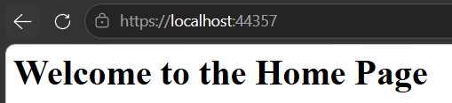
Visiting /admin without login redirects to login page
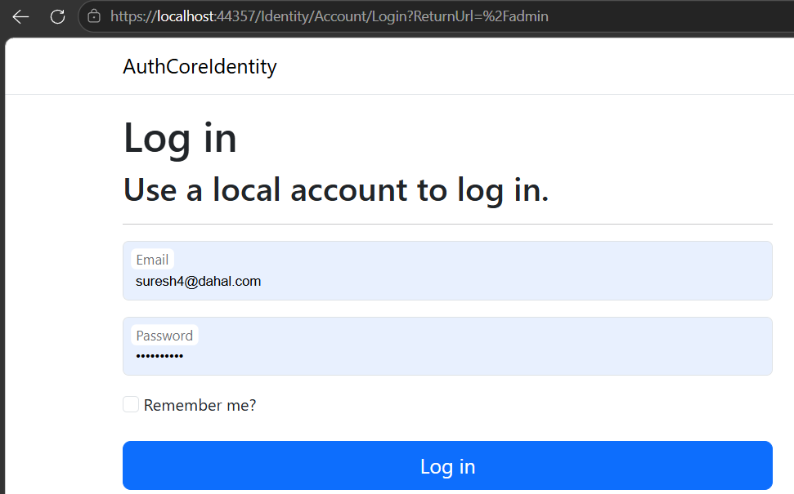
[AllowAnonymous] allows visiting public endpoint inside admin controller
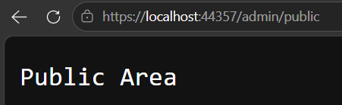
Admin route, protected by role
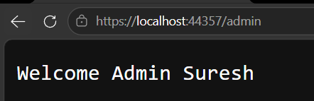
Faculty route, protected by policy
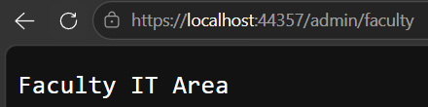

- Common Web Application Vulnerabilities and Prevention
THEORY:
ASP.NET Core provides several security features for protecting web applications from unauthorized access and common attacks. These include authentication, authorization, input validation, output encoding, anti-forgery protection, secure database access, and safe URL handling.
Common web application vulnerabilities include Cross-Site Scripting (XSS), SQL Injection, Cross-Site Request Forgery (CSRF), and Open Redirect attacks.

1. Cross-Site Scripting (XSS)
XSS occurs when an attacker injects malicious script into a web page through user input. If the application displays the input without proper encoding, the script may be executed in the user's browser.
For example: <script>alert('XSS')</script>
Prevention
- Validate user input.
- Encode output before displaying it.
- Avoid Html.Raw() with untrusted data.
- Sanitize HTML when accepting HTML content is necessary.
ASP.NET Core Razor automatically HTML-encodes normal output, providing protection against many XSS attacks.

2. SQL Injection
SQL Injection occurs when user input is directly included in an SQL query. An attacker may manipulate the input to change the intended SQL command.
An example of unsafe query:
"SELECT * FROM Users WHERE Username = '" + username + "'"
Prevention
- Use Entity Framework Core.
- Use parameterized queries.
- Never concatenate untrusted input directly into SQL.
- Validate input where appropriate.
3. Cross-Site Request Forgery (CSRF)
CSRF occurs when an attacker causes a user's browser to send an unwanted request to a website where the user is already authenticated.
ASP.NET Core MVC provides anti-forgery tokens to ensure that a request originated from the legitimate application.
Prevention
Use:
[ValidateAntiForgeryToken]
on sensitive POST actions.
ASP.NET Core's Form Tag Helper can automatically include the anti-forgery token in forms.

4. Open Redirect
An Open Redirect vulnerability occurs when an application redirects a user to a URL supplied by the user without checking whether the destination is trusted.
For example:
/login?returnUrl=https://malicious-site.com
An attacker could use such a link to make a trusted application appear to redirect users to a malicious website.
Prevention
Use:
Url.IsLocalUrl(returnUrl)
to verify that the destination is local, and use:
LocalRedirect(returnUrl)
for safe local redirection.

PROGRAM:

1. Install ADO.NET SQLite Package
dotnet add package Microsoft.Data.Sqlite

2. Program.cs
var builder = WebApplication.CreateBuilder(args);
builder.Services.AddControllersWithViews();

var app = builder.Build();

app.UseHttpsRedirection();
app.UseStaticFiles();
app.UseRouting();

app.MapControllerRoute(
name: "default",
pattern: "{controller=Security}/{action=Index}/{id?}");

app.Run();

3. SecurityController.cs
using Microsoft.AspNetCore.Mvc;
using Microsoft.Data.Sqlite;

namespace SecurityDemo.Controllers;

public class SecurityController : Controller
{

private readonly string connectionString =
"Data Source=security.db";

private void InitializeDatabase()
{
using var con = new SqliteConnection(connectionString);
con.Open();

string sql = """
CREATE TABLE IF NOT EXISTS Users (
Id INTEGER PRIMARY KEY AUTOINCREMENT,
Username TEXT NOT NULL,
Password TEXT NOT NULL
);

INSERT OR IGNORE INTO Users
(Id, Username, Password)
VALUES (1, 'admin', '1234');
""";

using var cmd = new SqliteCommand(sql, con);
cmd.ExecuteNonQuery();
}

public SecurityController()
{
InitializeDatabase();
}

public IActionResult Index()
{
return View();
}

// ---------------- XSS ----------------

[HttpPost]
public IActionResult Xss(string name)
{
if (string.IsNullOrWhiteSpace(name))
{
ViewBag.XssResult = "Name is required.";
return View("Index");
}

ViewBag.XssResult = name;

return View("Index");
}

// ---------------- SQL INJECTION ----------------

// Vulnerable example
[HttpPost]
public IActionResult UnsafeLogin(
string username, string password)
{
using var con = new SqliteConnection(connectionString);

string sql =
$"SELECT COUNT(*) FROM Users " +
$"WHERE Username='{username}' " +
$"AND Password='{password}'";

using var cmd = new SqliteCommand(sql, con);

con.Open();

int count = Convert.ToInt32(cmd.ExecuteScalar());

ViewBag.SqlResult =
count > 0
? "Login successful (unsafe query)."
: "Invalid login.";

return View("Index");
}

// Secure parameterized query
[HttpPost]
public IActionResult SafeLogin(
string username, string password)
{
using var con = new SqliteConnection(connectionString);

string sql =
"SELECT COUNT(*) FROM Users " +
"WHERE Username=@username " +
"AND Password=@password";

using var cmd = new SqliteCommand(sql, con);

cmd.Parameters.AddWithValue(
"@username", username);

cmd.Parameters.AddWithValue(
"@password", password);

con.Open();

int count = Convert.ToInt32(cmd.ExecuteScalar());

ViewBag.SqlResult =
count > 0
? "Login successful (parameterized query)."
: "Invalid login.";

return View("Index");
}

// ---------------- CSRF ----------------

[HttpPost]
[ValidateAntiForgeryToken]
public IActionResult Submit(string message)
{
ViewBag.CsrfResult =
"Request accepted. Anti-forgery token is valid.";

return View("Index");
}

// ---------------- OPEN REDIRECT ----------------

// Vulnerable
public IActionResult UnsafeRedirect(string url)
{
return Redirect(url);
}

// Secure
public IActionResult SafeRedirect(string url)
{
if (Url.IsLocalUrl(url))
return LocalRedirect(url);

ViewBag.RedirectResult =
"External URL blocked.";

return View("Index");
}
}

4. Index.cshtml
<h1>ASP.NET Core Security Demo</h1>

<hr />

<h2>1. XSS Attack and Prevention</h2>

<form asp-action="Xss" method="post">

<input name="name"
placeholder="Enter name" />

<button type="submit">
Submit
</button>

</form>

@if (ViewBag.XssResult != null)
{
<p>
Output:
@ViewBag.XssResult
</p>
}

<p>
Test input:
<code>&lt;script&gt;alert('XSS')&lt;/script&gt;</code>
</p>

<hr />

<h2>2. SQL Injection</h2>

<h3>Unsafe Login</h3>

<form asp-action="UnsafeLogin" method="post">

<input name="username"
placeholder="Username" />

<input name="password"
placeholder="Password" />

<button type="submit">
Unsafe Login
</button>

</form>

<h3>Safe Login</h3>

<form asp-action="SafeLogin" method="post">

<input name="username"
placeholder="Username" />

<input name="password"
placeholder="Password" />

<button type="submit">
Safe Login
</button>

</form>

@if (ViewBag.SqlResult != null)
{
<p>@ViewBag.SqlResult</p>
}

<p>
SQL Injection test:
<code>' OR '1'='1</code>
</p>

<hr />

<h2>3. CSRF Protection</h2>

<form asp-action="Submit" method="post">

@Html.AntiForgeryToken()

<input name="message"
placeholder="Enter message" />

<button type="submit">
Submit
</button>

</form>

@if (ViewBag.CsrfResult != null)
{
<p>@ViewBag.CsrfResult</p>
}

<hr />

<h2>4. Open Redirect</h2>

<h3>Unsafe Redirect</h3>

<a href="/Security/UnsafeRedirect?url=https://example.com">
Test Unsafe Redirect
</a>

<h3>Safe Redirect</h3>

<a href="/Security/SafeRedirect?url=/Security">
Test Safe Local Redirect
</a>

@if (ViewBag.RedirectResult != null)
{
<p>@ViewBag.RedirectResult</p>
}

OUTPUT:

JavaScript is not executed.

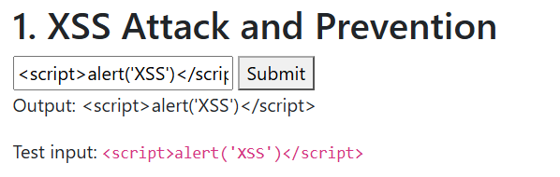

Unsafe login (SQL Injection)

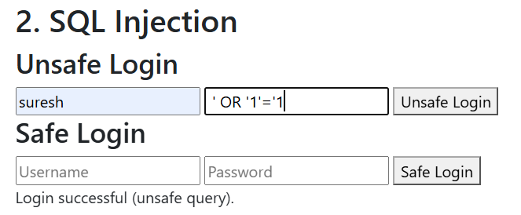

SQL Injection Prevented

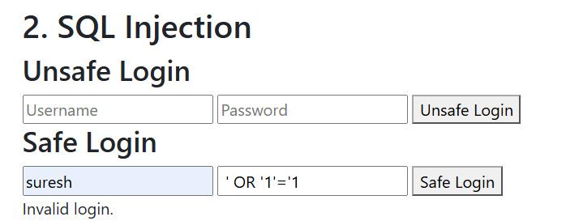

CSRF Token Passed.

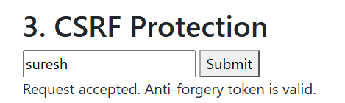

Open Redirect Vulnerability (redirects to external website)

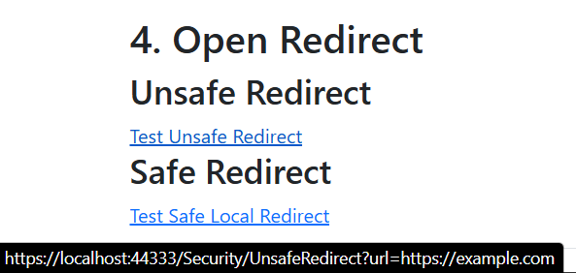

External Redirection Blocked

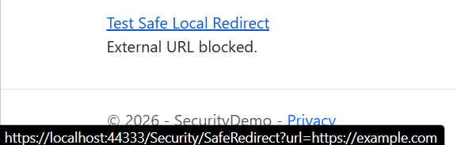

Unit – 9

1. Hosting and Deploying ASP.NET Core Application

1. Theory

ASP.NET Core Hosting
Hosting means running an ASP.NET Core application on a server so that users can access it. Kestrel is the default web server of ASP.NET Core. In production, Kestrel is commonly used behind a reverse proxy such as IIS, Nginx, or Apache.
Client
↓
IIS / Nginx / Apache
↓
Kestrel
↓
ASP.NET Core Application

Hosting Models
Server | Description
IIS | Microsoft's web server for Windows and supports ASP.NET Core through ANCM.
Nginx | High-performance web server, commonly used as a reverse proxy on Linux.
Apache | Cross-platform web server that can work as a reverse proxy for Kestrel.
Kestrel | Default, cross-platform ASP.NET Core web server.

ASP.NET Core Module
The ASP.NET Core Module allows IIS to host ASP.NET Core applications. IIS receives the request and ANCM forwards it to the ASP.NET Core application running through Kestrel.
Client → IIS → ANCM → Kestrel → ASP.NET Core

2. Deployment Procedure

Step 1: Build
dotnet build -c Release

Step 2: Publish
In Visual Studio:
- Right-click the project in Solution Explorer.
- Select Publish.
- Select Folder.
- Select Release configuration.
- Click Publish.
The published files are generated in a folder such as:
bin\Release\net10.0\publish\

Step 3: Deploy and Run
- Create C:\inetpub\SecurityDemo
- Paste content from bin\Release\net10.0\publish\
- Install IIS Server
- Open Inet Manager
Win + R -> inetmgr
- Add application pool
- Add website
- Run the website

3. Docker Containerization
Docker packages the application and its required runtime into a container.
ASP.NET Core
↓
Dockerfile
↓
Docker Image
↓
Container
↓
Kestrel
Build Dockerfile:
FROM mcr.microsoft.com/dotnet/sdk:10.0 AS build
WORKDIR /src
COPY . .
RUN dotnet publish -c Release -o /app/publish

FROM mcr.microsoft.com/dotnet/aspnet:10.0
WORKDIR /app
COPY --from=build /app/publish .
ENTRYPOINT ["dotnet", "SecurityDemo.dll"]
Build and run:
docker build -t securitydemo .
docker run -p 8080:8080 securitydemo

OUTPUT:
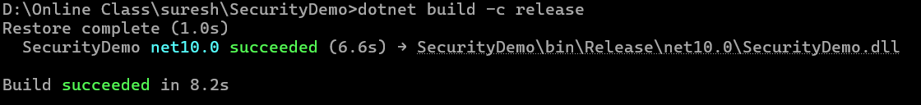

Publish to Local Folder
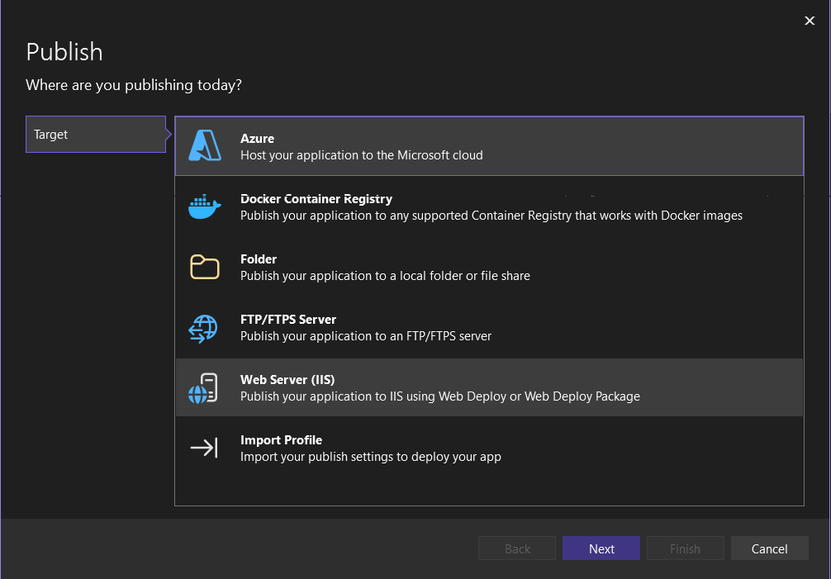
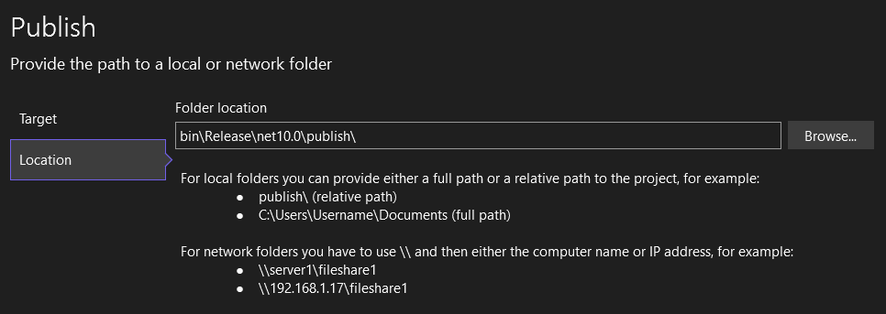
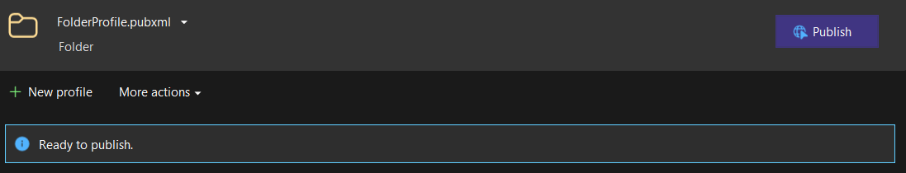
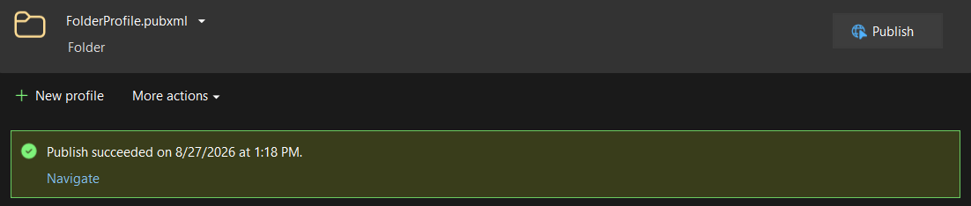
Add Application Pool
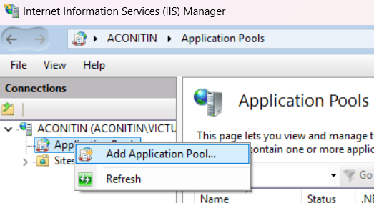
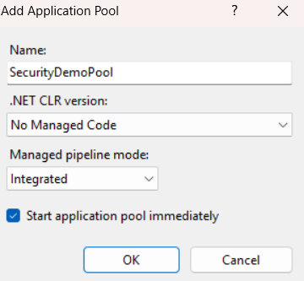
Add Website
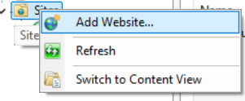
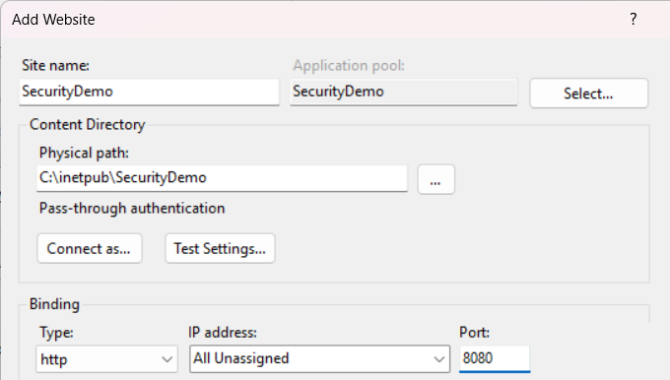
Accessing Website Hosted on IIS
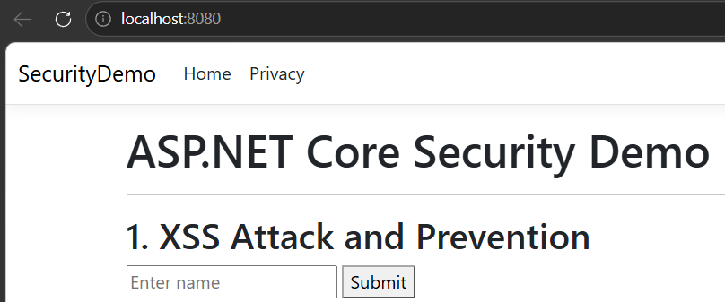
Publish using Docker
Building Docker Image
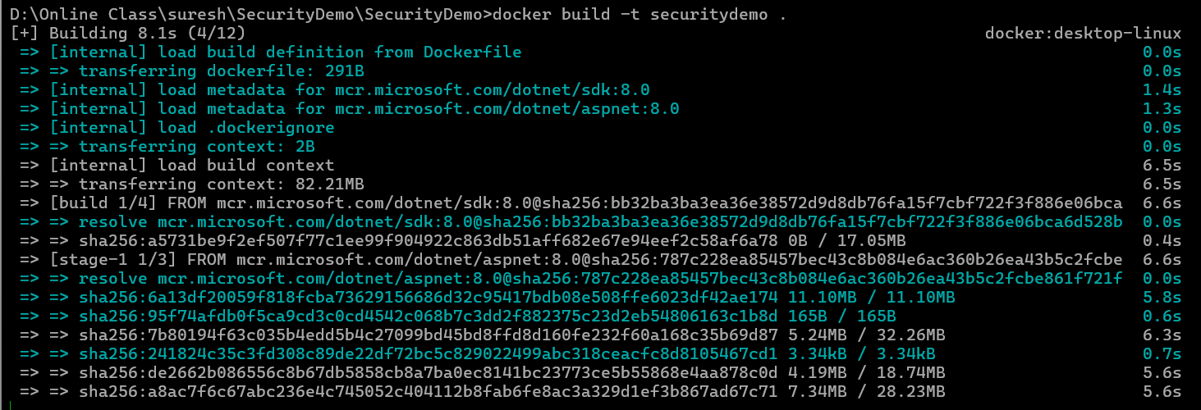

Running Docker Image
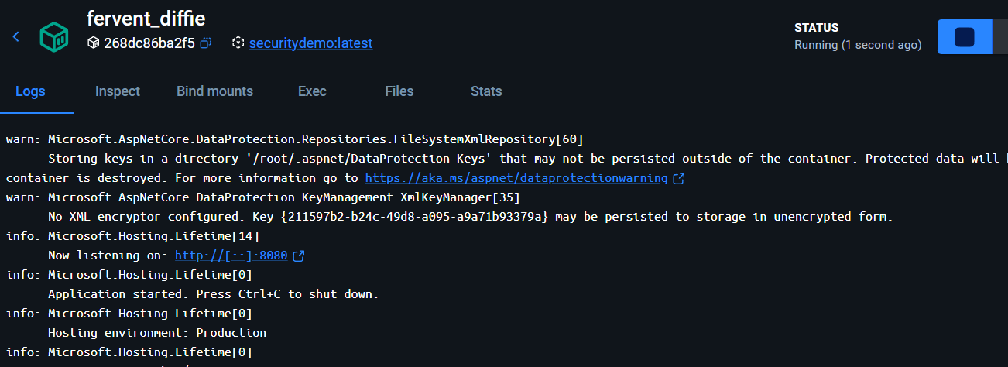

Visiting Website Through Docker
